Open Space Committee Minutes November 17, 2020
Present: Rick Gardner, Cary LeBlanc, Deb Cary, Kelton Burbank, Karen Rossow
Alternate: Susan Downing
Absent:

Meeting began at 7:05 pm on Goto Meeting.
- Minutes of October 13, 2020 meeting were approved.

- Trail Vision and Action Plan:
  - Survey: Survey is just about ready. We discussed multiple choice options and decided to leave the questions open ended. On ‘connection question’ we should add an example of what we are looking for. The sub-items on question 1 need to be numbered. Susan will finalize the questions and format and send to the vision team for review.
  - Signage: The sub-committee met once and discussed options for signage. Next step is to check out all trails and make a list of needs/opportunities. We also will be looking at examples from other towns. Deb will schedule follow up meeting. Intent is to set standards for various aspects of signage.
  - Communications/Publicity and Landowner sub-committees. We reviewed Cary’s scope and goals statement, looks good. Will be looking at ways to improve the website, make Princeton folks more aware of trails and options, and look at communicating better and promoting the trails. Cary will be setting up a sub-committee meeting.
  - Landowners sub-committee: Kelton has had trouble getting this going due to his schedule. Rick will jump in on this during the next month. Kelton mentioned that we already have a lot of information on this topic.

- TAP
  - CHCA: We are nearly done at CHCA. Hoping to get the bridges in before the snow. That will leave only the wetland replication work to be completed in the spring.
  - Goodnow Park: OSC members and Trail Steward members cleared the trails and Rick showed photos of the cleared trails. OSC idea is to add a couple of benches and perhaps picnic tables. Low key approach. Parks and Rec Commission is aware of this area and has no plans to get involved at this time. We decided to invite neighbors for a tour of the trails and a discussion of ideas. Rick will pull together a list of neighbors and work toward a communication to that end. After the neighbor activity we will consider marking the trails and working on signage and benches.
  - Red Fox Farm: No change in the past month. We are still planning to work with Walcotts but need to wait and see on another possible approach through Princeton Land Trust.
  - Worcester Road West: Walk throughs with Tom Sullivan and Brian Keevan have been done. Rick has made a modification to the trails to keep more of the trail on PLT property. Brian Keevan is arranging a walk through with the Conservation Commission (PCC). They will need to decide if modifications are required to the wetlands. If NO, we can proceed but will need to advertise a legal notice to file a Request for Determination of Applicability (RDA). If yes, then we will also need to go through the NOI process which is quite a bit more complex and expensive.
    - Voted: Approved spending money for posting a legal notice if needed for the RDA process (to be determined after walk through with PCC).

- Trail Map: Rick has made some progress with use of AllTrails. He did a brief demo.
  - PLT and CHCA trails were added to the base map (Open Street Map). It took a few months for these changes to be brought into AllTrails
  - Added six or seven hikes to various areas of town.
  - We looked at a wide view of AllTrails and a view of some of the new trails that were added.
  - Rick is thinking that we can replace a lot of the custom work on the website with references to AllTrails. OSC members will look at AllTrails and we can discuss how to proceed. This will also be a topic for our communications/promotions sub-committee.

- Princeton Hikes continue to work well. Recent and future hikes are summarized below
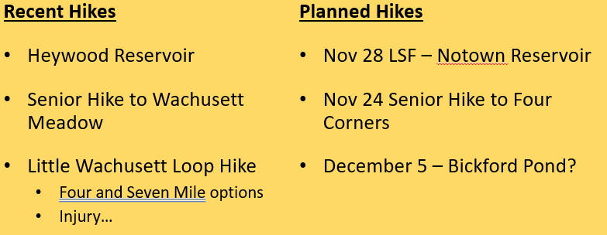

- Next meeting: Plan for December 15th.

- Meeting adjourned at 8:20 p.m.

- Summary of outstanding to-do items:

  - Rick: Obtain OSRP Copies. Marie will help.
  - Rick: Third meeting of the Trail Visioning and Action Plan project. Agenda will be: status and initial feedback on trail ideas.
  - Rick: Continue analysis of Trail Mapping plans
  - All: Follow up on assigned tasks for the Trail Vision and Action Plan
  - All: Get comments to Rick about use of AllTrails.
  - Trail Action Plans:
    - Deb and Tom are going to focus on trying to figure out the Bullock Lane to TPS link.
    - Rick will work on inviting neighbors to tour the park and help with ideas.
    - Rick to follow up with access to Red Fox link
    - Rick and Deb to work Worcester Road West trails.
Respectfully submitted, Rick Gardner

